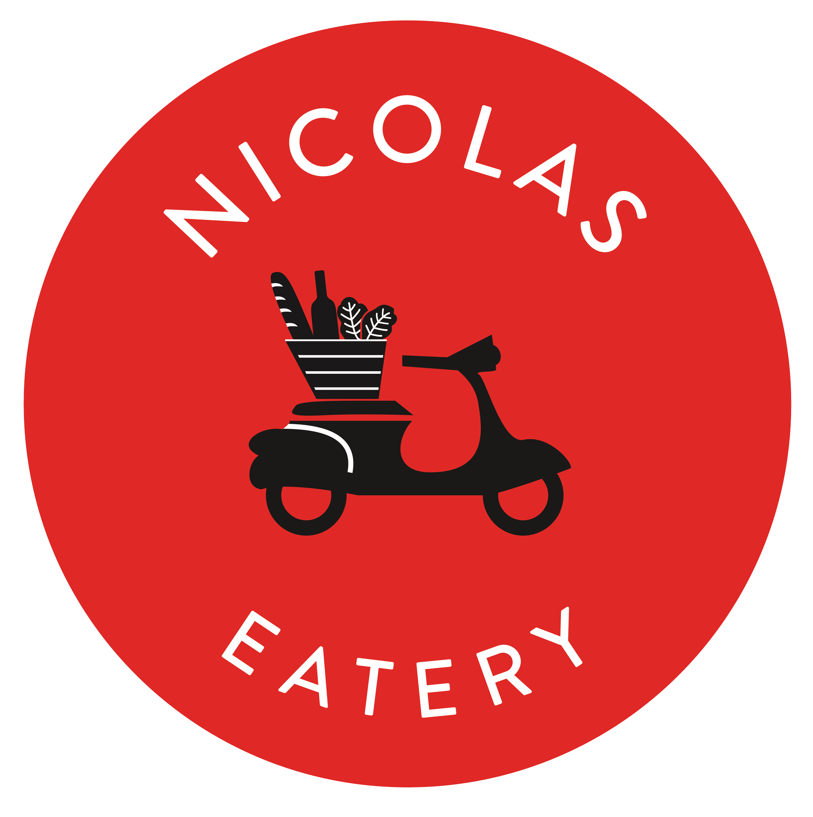

CANAPES MENU

CHOOSE:
3 FOR $14 PER PERSON
4 FOR $17 PER PERSON
5 FOR $20 PER PERSON
6 FOR $24 PER PERSON

MUSHROOM FUNDIDO
Portobello, Oyster Mushrooms, French Bread

KLAUS’ CAULIFLOWER
Fried Cauliflower Poppers

LOBSTER ROLL
Lobster Claw & Champagne Sauce

FRIES & DIPS
Bu, Carbon Beach, Ketchup, Mayo

CHICKEN WINGS
House made sweet chili sauce

AVOCADO TOAST
smashed avocado, lemon, tomatoes

Steak Tartar (+2 per person)

Beef & Fried Chicken Slider

